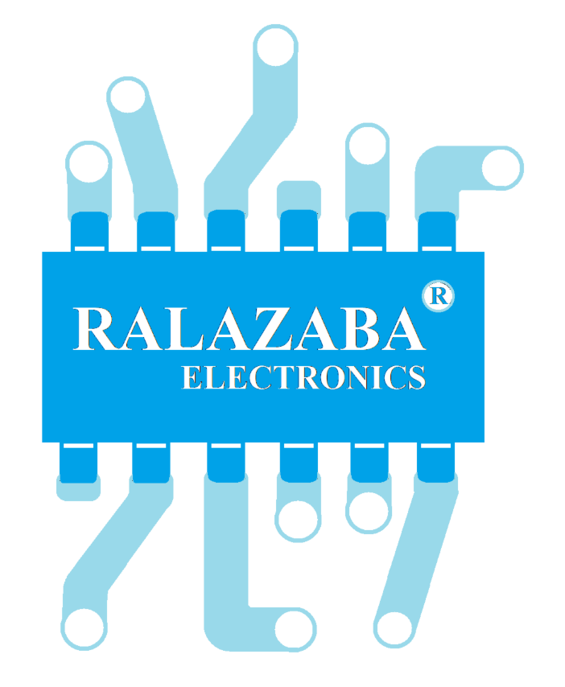

**RaLaZaBa Electronics**

**Device trying to extract the plan of their surroundings**

PROJECT AMR01

Prepared for

Assoc. Prof. Lale ALATAN

|  |  |  |  |
| --- | --- | --- | --- |
| Ali AYDIN | 2093326 | +90 538 823 0103 | ali.aydin@metu.edu.tr |
| Anıl AYDIN | 2030179 | +90 531 861 1820 | anil.aydin@metu.edu.tr |
| Enes AYAZ | 2093318 | +90 538 978 8499 | enes.ayaz@metu.edu.tr |
| Nail TOSUN | 2094563 | +90 532 687 1699 | nail.tosun@metu.edu.tr |
| Selman DİNÇ | 2093722 | +90 537 678 3584 | selman.dinc@metu.edu.tr |

**Project Start Date:** 30.10.2018 **Project Completion Date**: 18.05.2019

**Project Duration:** 7 Months

Table of Contents

EXECUTIVE SUMMARY…………………………………...…………………1

INTRODUCTION……………………………………………………………….2

TEAM ORGANIZATION………………………………………………………3

REQUIREMENT ANALYSIS………………………………………………….4

STANDARDS…………………………………………………………………...6

SOLUTION PROCEDURE……………………………………………………..6

DELIVERABLES……………………………………………………………….8

* Documents………………………………………………………………...8
* Technical Support…………………………………………………………8
* Equipment………………………………………………………………...8

CONCLUSION………………………………………………………………….9

APPENDIX A: GANTT CHART………..…...………………………………..10

**EXECUTIVE SUMMARY**

Robots could one day navigate through constantly changing surroundings with virtually no input from humans, thanks to a system that allows them to build and continuously update a two or three-dimensional map of their environment using low-costs sensors. As the science progress, some researchers want to observe harsh environments like *caves with toxic gases, deep underwater surfaces and space environments.*

Our company, *RaLaZaBa Electronics,* is developing robots that extract maps to help to scientists and engineers to explore unknown environments with a *reasonable price (under $200)* and *great robustness.*

Our company can provide a great and cheap solution to the problem stated by Electrical- Electronics Engineering department of METU. The required mapping solution of the environment in Mars can be realized by AMR Project. The environment is supposed to be mapped for the experimental tools, which will be oriented by the shape of the objects in the specified environment. We have created their sub-problems and possible solutions. These sub-problems are stated as the following

* Detection of the position and orientation of the surroundings and targets.
* Detection of the position of the vehicle.
* Designing fast, agile and accurate actuator system.
* Optimizing searching algorithm that minimize the time for mapping.

Our approach to these problems may be summarized as;

* A possible list for solutions of the **detection of position and orientation of the surroundings and targets**
  + **Using LIDAR to sense shape of objects and distances**
  + **Using Camera to sense shape of objects and distances**
  + **Using distance sensor with encoding motor to sense shape of objects and distances**
* A possible list for solutions of the **detection of position of the vehicle** 
  + **Using infrared sensor (used in mouse) to sense 2D movement**
  + **Using ball caster to sense 2D movement**
  + **Using encoder motors to sense 2D movement**
* A possible list for solutions of the **fast, agile and accurate actuator system** 
  + **Minimizing weight of robot**
  + **Using high power motors**
* A possible list for solutions of the **optimizing searching algorithm that minimize the searching time**
  + **Using probabilistic model to create non-repetitive route**
  + **Real time mapping analysis to comprehend route**

RaLaZaBa Electronics has an interdisciplinary team that consists of control systems specialist, hardware and software experts. The team has experiences on *robotics* *contests* like *autonomous RC cars* and *IEEE contests.* Therefore, the team has adequate know-how about the project. Since we have adequate ability to fulfil the requirements, we will deliver the end product before its journey to Mars. The project progress is shown in Appendix A.

**INTRODUCTION**

        Nowadays, map is one of the greatest inventions since we are not lost if we follow directive of map correctly. To map some places, we can use satellite photo or draw top view. Also, we can use some electronic devices such as drones to achieve our goals. What happens if we want to explore a planet and map its surrounding. We cannot use drones due to lack of atmosphere. We can use satellite or a robot. AMR is going to be produced for these purposes.

As RaLaZaBa Electronics we are interested in doing that kind of autonomous mapping robots which will lead this new sector. Our autonomous robot does not need to fly. It moves on the ground and it can identify objects and specify their exact positions in the interested area by sensing the environment and convert the information collected from area to a 2-D map.

During the project AMR, we are supposed to satisfy the requirements of Electrical- Electronics Engineering department of METU. The project is an answer to mapping requirement of the Mars environment that is used to place experimental equipment. This equipment is placed by the shapes of the objects, meaning that mapping of the environment and object detection are emphasized.

In this project, sensing environment takes an important role. A device or robot is supposed to sense its environment and extracts the plan of its surrounding from this sense. The device rambles on the environment and creates a plan of the area. The mapping plan is the output of the device. On the other hand, device produces only map data and we do not control device. For now, to examine the robot, we will use a place which is surrounded by 12 walls and there will be some objects in the area. The robot will not be higher than objects. Our purposes in this examination is that robot should complete drawing area at the shortest time.

This project can be considered as challenging. However, we, RaLaZaBa Electronics, will confidently solve the problem, since we have enough experience, engineering skills and creative ideas. Our members are highly motivated to make this robot.

**TEAM ORGANIZATION**

Our company RaLaZaBa Electronics have 5 members. Each engineer has theoretical and practical knowledge in their areas. Also, all of them are suitable for the work distribution of the project. The organization of RaLaZaBa Electronics is shown in Figure 1.

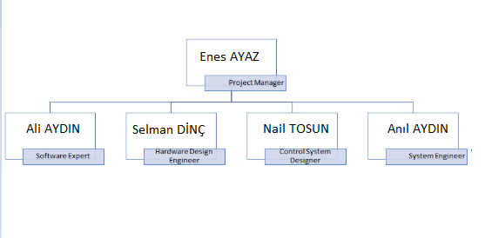

Figure 1: Organization Tree of our company

**Ali Aydın**

Ali uses **Python** and MATLAB most often for software projects. He has experienced with C# for designing user interface software. He is currently working on **C++** and **C** for DSP applications of motor drives under Research League. He used **Verilog** for FPGA coding.

**Anıl Aydın**

He uses C and Python most often for software projects. He has experienced with C# for designing user interface software. He is currently working on microcontrollers and microprocessors like Arduino and **Raspberry PI**. He is also experienced with image processing applications during his summer internship. Moreover, he worked on **MATLAB Simulink** applications which will be helpful for the simulations of our subsystems.  He has experienced with **Altium** for PCB design. Besides, he used Verilog for FPGA coding.

**Enes Ayaz**

He worked IEEE RAS mostly on **robotics** and embedded systems. He gives lecture about robotics as mentor in RAS. At his first internship he worked on **image process** and **deep learning.** He attended workshops about **image process** (*OpenCV*), segmentation and **ROS** in Openzeka autonomous RC car contest. He used Python in many projects mostly on *Tensorflow and Keras*. He is working on GaN transistors and its physical and mathematical models on **Simulink** in Research League, *Dr. Ozan Keysan’s research group*.

**Nail Tosun**

Nail, is working now with Dr. Ozan Keysan research group Research League under Powerlab. While he working on thermal design and analysis of **electric motors**, he works also solar power estimation using ANN with Dr. Murat Göl under METU EE STAR. He attended workshops about **image process**, segmentation, **the control theory** and introduction to ROS in Openzeka autonomous RC car contest. He works different software project mainly about **Python** or **MATLAB**. He has experiences about web development. He used HTML5, CSS3, **JavaScript**, PHP in his web development projects.

**Selman Dinç**

He worked on mainly embedded systems and RF links. He has a good command of C++ and MATLAB. He worked as a system engineer during his internship. He worked with CAD programs and he is currently working on Altium Designer. He also knows Verilog HDL.

**REQUIREMENT ANALYSIS**

The project is improved to use in harsh environments of Mars. The places is hard to maintain vital activity. So, the robot is alone in work area and there is no driver inside. For all reasons, the robot has no chance to make a mistake. Thus, the project has some requirements that restrict the design, and implementation to ensure robot to work properly. The requirements can be separated 2 branches. One is called ‘Mandatory’ that is forced. Other one is ‘voluntary’ that is free to make or not.

Mandatory features:

* Robustness
* Long operating time
* Autonomous
* Fast operation
* Operational safety
* Easy-to-use

Voluntary:

* High resolution
* Light weight

Mandatory Features:

Robustness: The robot must be robust because it works on duty in the harsh environment. The robot must endure until the duty finishes.

Long operating time: The robot continues its activity for at least 10 hours between two sequential refueling/charging. In addition to that requirement, it is supposed to consume minimum power and has to possess high density energy storage.

Autonomous: Communication between robot and server or user for real time is hard to implement at every condition in the harsh environment. Then, the robot must decide and plan your movement by autonomous.

Fast operation: Due to the harsh environment, the robot may be damaged after it is deployed. This leads the mapping operation should be completed in a shortest time.

Operational safety: The device is designed to equip short circuit protections and proper insulation to prevent fatal injuries.

Easy-to-use: The system should be user friendly. After deployment, the mapping output may be needed to transferred to user by a digital medium.

Voluntary:

High Resolution: The aim is to sketch, plot outline of the environment and determine the target objects. The high resolution provides with more precision.

Light: The robot will send to environment and the transportation progress changes cost and feasibility of the project. Weighty devices may not send to space and the weight of robot is crucial at that point.

**STANDARDS**

Robots compete each other with respect to minimum time for proper map wins the competition. Some definitions about regions, blocks and robots are described. However, physical properties of walls and blocks are left to standard committee.

Rules:

* There is 12 wall pieces with 50 cm long. The pieces are bringing from each group by half.
* There are 8 objects (4 different object)

1. Cylinder with 10 cm diameter.
2. Cylinder with 5 cm diameter.
3. Square prism with an 7cm edge length.
4. Prisms with an equilateral triangular base of 8 cm edge length.

* Any camera or sensor must be on board the device.
* Robots should have maximum 25 cm diameter and height cannot be higher than blocks.
* No communication is allowed between device and outside world.

Standards:

* All objects and walls must be of the same commonly accepted (*) color.
* The height of the objects will be agreed upon (*)
* Time is main competition but there can be an evaluation rubric that is standardize the score.

**SOLUTION PROCEDURE**

The robot that extracts plan of surrounding consists of four blocks. The blocks are called Sensing Unit, Control Unit, Measurement Unit and Mapping Unit. Sensing unit brings the signal from surroundings and this is helper for creating route of robots. Control unit make a decision to move at route. Measurement unit data extracts the feature of surroundings and objects. Mapping unit takes measurement and sensing data to create a plan of surroundings.

At this point, there is some solution methods to use in units.

Sensing Unit:

* Camera can be used to find the route that is not filled by objects. Camera and its module can be obtained for 10 dollars.

Milestone:

* Detect the object with respect to color.
* Capture the space of objects.
* IR laser distance sensor can be used find route that is not filled by object. One module can be acquired for 0.5 dollar.

Milestone:

* Measure the distance between static two points.
* Measure the distance between one point to radial of points by radial motion.

Control Unit:

* Dc motor with encoder can be used to move robots. They cost 5 dollar each.

Milestone:

* Measure the speed of dc motor.
* Step motor can be used to move robots. The cost is around 2 dollar each.
* Microcontroller needed to process sensing unit data.

Milestone:

* With dummy data, drive the motors.
* Reading encoder data to find speed.

Measurement Unit:

There are two information to extract plan. One of them is object position and other one is vehicle position.

            Object position:

* LIDAR can be used to find objects features. For the budget of 200 dollar, the LIDAR module can be hand crafted for 50 dollars. Normally, they cost 200 dollar each.

Milestone:

* The module has to be built.
* The measurement must be established

* Step or servo motor with distance sensor can be used to find objects. The sensor can be built for 14 dollars.

Milestone:

* + Measure the distance by distance sensor.
  + Measure the distance while move radially.
* Camera can be used to find objects. The camera modules with 480-pixel wide sensor is available for 2 dollars.

Milestone:

* Object detection using the camera.

Robot position:

* Robot position can be found by encoder with dc motor.
* Optic Sensor (used in PC mouse to find movement of 2D plane.)

Milestone:

* Reading position data by using “USB”
* Data is processed on the computer

Mapping Unit:

* The unit have a microprocessor that processes measurement unit data and create 2D map and send it to user.

The solution methods will be tested and chosen with respect to plus and minuses. Proposal of solution can be changed if more advantageous and feasible solutions is found.

**DELIVERABLES**

**Documents**

**Manual**: Our company give a user manual for users. Manual contains information about hardware, software components and describes usage of the device.

**Technical Support**

Our company gives 24/7 technical support by Selman Dinç. The support is accepted via e-mail communication.

**Equipment**

**Device**: Robot is provided for users

**Platform**: 6 walls and 4 objects will be provided for users

**Battery and Charging Unit:** We will provide chargeable battery to run the robot.

**Software**

**Interface:** We will provide a software package which contains a user interface to see a readable map from a screen.

**CONCLUSION**

RaLaZaBa Electronics will design an autonomous robot which extract map around its surroundings. This product can be used in many different areas such as rescue operations, cave or subsoil research field, space explorations. Many products taken place in this market. However, their cost/price ratio is adequate. That’s why we want to get into this business. We, as RaLaZaBa Electronics offer fully-autonomous, robust, low-power, low-cost product to customers.

The problems are offered as determining the position of both vehicle and its surrounding, effective usage of moving actuators and designing a search algorithm to optimize itself to find minimum path to extract the map with different surroundings.

To solve the problems, we will first classify the problems with their needed know-how.

When the project is finished, this will bring a new approach to rescue operations, space explorations or research at harsh environments. With the help of the robustness and low-cost our technology will easily diffuse the market. At near future, this autonomous robot can be anywhere in any application.

We, as RaLaZaBa Electronics, guarantee that we will provide you to best product according to standards.

**APPENDIX A: GANNT CHART**

